**5. Object Modelling**

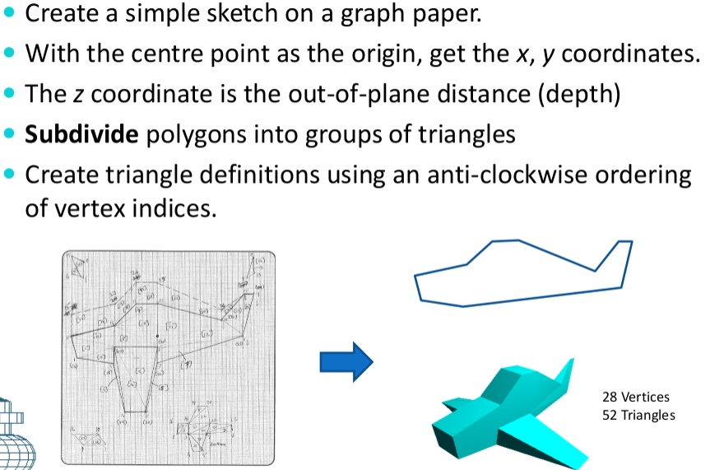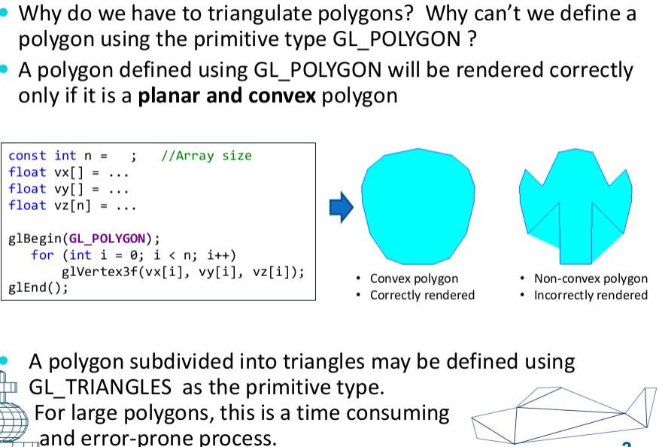interior angle of a **convex** angle is less than and equal to 180 deg

**Primitive Types for Triangulation**

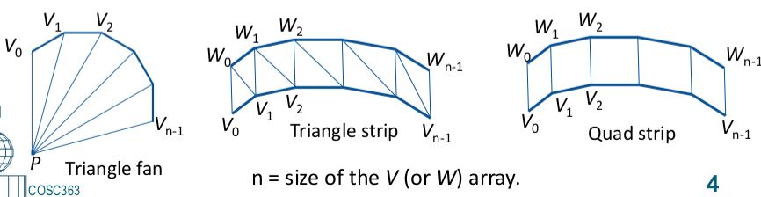- GL_TRIANGLE_FAN

- GL_TRIANGLE_STRIP

- GL_QUAD_STRIP

-provides a compact representation

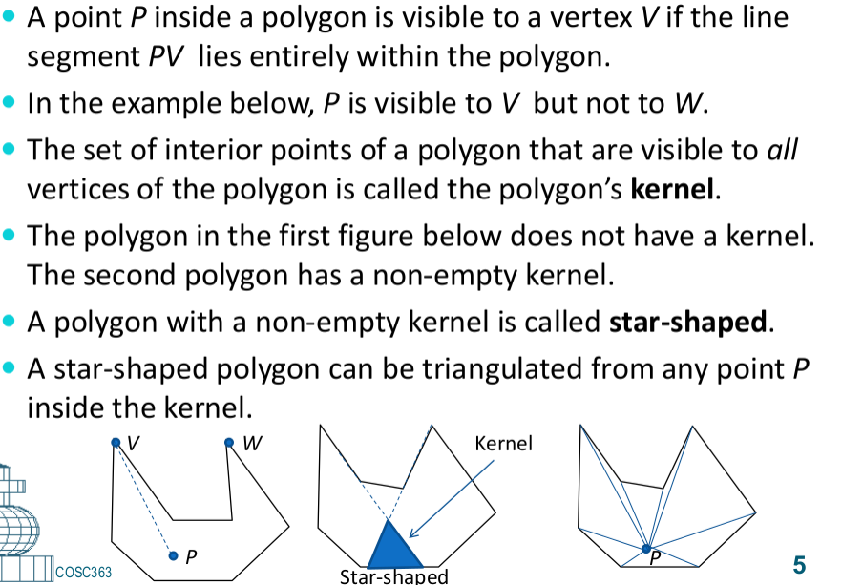**Visibility and Kernel of a Polygon**

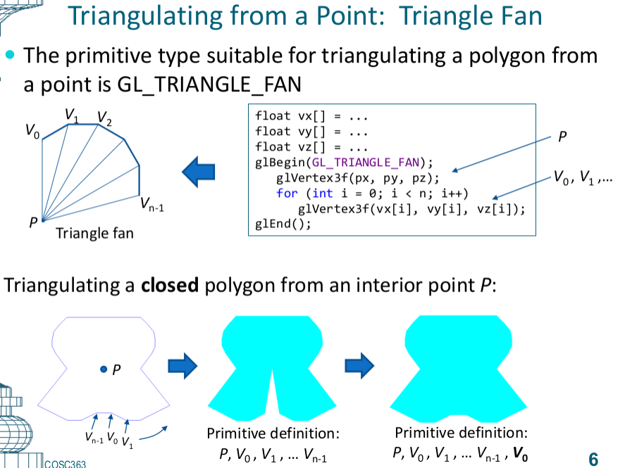kernal = very point sees every vetex in the shap

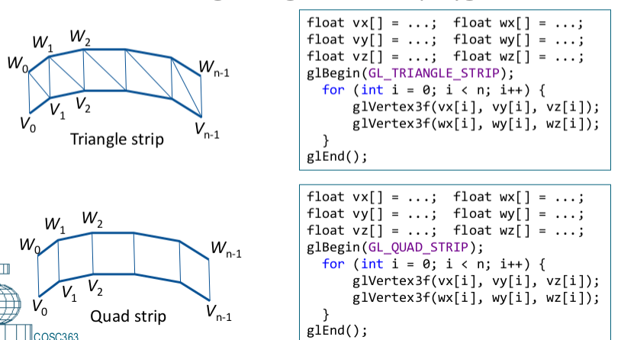**Polygon Strips**